5/30/2023

**Complied by: Gelareh Kabiri**

**Determinants of Firm Leverage and the Impact of Brexit**:

***An Empirical Analysis***

## **INTRODUCTION**

According to BBC News (2020), Brexit, which stands for "British exit," refers to the withdrawal of the United Kingdom (UK) from the European Union (EU) and the European Atomic Energy Community. The decision was made following a referendum held on June 23, 2016, in which a majority of UK voters chose to leave the EU. This historic event has had significant political, economic, and social implications, not only for the UK but also for the EU and the global community.

This was done by invoking Article 50 of the Lisbon Treaty. Following that, while talks on the terms of the UK's exit were ongoing, the UK continued to abide by EU laws and regulations during a transitional phase. A new trade deal between the UK and EU went into effect on January 1, 2021, after the UK officially left the EU on January 31, 2020. Brexit, the UK's historic vote to leave the European Union, is a prime example of how political and financial turbulence in one nation may spread to harm businesses in other countries and around the world. However, it is unclear how these shocks will affect the global economy, particularly for policymakers and politicians who are trying to find solutions.

Sampson (2017), Graziano et al. (2021), and Broadbent et al. (2019), among others, try to quantify Brexit's effects on businesses in UK enterprises.

The significance of studying the impact of Brexit on firm leverage lies in understanding how this major political and economic shift affects the financial structure and risk-taking behaviour of companies. Firm leverage, measured by indicators such as debt-to-equity ratios or leverage ratios, provides insights into the extent to which companies rely on debt financing to fund their operations and investment activities. Changes in firm leverage can reflect adjustments in capital structure choices, risk management strategies, and overall financial stability.

The objective of the analysis is to examine the impact of post-Brexit on firm leverage, considering the specific hypotheses related to this research question. Based on the regressions and tests which will be provided, the following hypotheses can be formulated:

***Hypothesis 1: Post-Brexit period has a significant impact on firm leverage****.*

*Null hypothesis (H0):* Post-Brexit period has no significant impact on firm leverage.

*Alternative hypothesis (HA):* Post-Brexit period has a significant impact on firm leverage.

***Hypothesis 2:* The treatment group (companies affected by Brexit) and control group (companies unaffected by Brexit) have different changes in leverage over time.**

*Null hypothesis (H0):* There is no significant difference in leverage changes between the treatment and control groups.

*Alternative hypothesis (HA):* There is a significant difference in leverage changes between the treatment and control groups.

These hypotheses aim to test the overall impact of the post-Brexit period on firm leverage, as well as to assess whether there are differential effects between the treated (Brexit-affected) and control (unaffected) groups. The specific regression models and tests conducted earlier provide empirical evidence to support or reject these hypotheses and shed light on the relationship between Brexit and firm leverage.

## **LITERATURE REVIEW**

The implications of Brexit have been far-reaching and have had significant consequences for both the UK and the EU. Brexit has had a profound impact on the economies of both the UK and the EU. Kotliński, K. (2018). The uncertainty surrounding Brexit negotiations and future trade arrangements has affected business confidence, investment decisions, and financial markets. The UK's departure from the EU's single market and customs union has resulted in trade barriers and changes in regulatory frameworks, which have implications for sectors such as manufacturing, services, and agriculture. Matthews, A. (2016). Brexit has also led to changes in the trading relationship between the UK and the EU. The UK's departure from the EU's single market and customs union means that trade between the two entities is subject to new customs procedures, tariffs, and non-tariff barriers. The UK has been negotiating new trade agreements with countries outside the EU, aiming to establish its trade policy.

Furthermore, Brexit has required the UK to review and amend its laws and regulations to replace EU legislation. This includes areas such as employment rights, consumer protection, environmental regulations, and financial services. Mugarura, N. (2018). The EU has also needed to adjust its regulations and policies to account for the UK's departure. It can also be observed that Freedom of movement, which allowed EU citizens to live, work, and study in the UK and vice versa, has been affected by Brexit. The UK has implemented new immigration policies and introduced a points-based system to control migration. Likewise, UK citizens' rights to live and work in EU member states have been subject to new regulations and requirements.

Lastly, Brexit has triggered political and institutional changes within the UK and the EU. In the UK, the decision to leave the EU led to the resignation of Prime Minister David Cameron and subsequent leadership changes. Ando, K. (2017). It also sparked debates on the future of the UK's devolved nations, with Scotland expressing a desire for another independence referendum. In the EU, Brexit has prompted discussions on the future of EU integration and reform (BBC NEWS, 2020).

## **METHODOLOGY**

The determinants of firm leverage, or the factors that influence a firm's decision to use debt financing, can vary depending on the context and the specific characteristics of the firm. However, some common determinants of firm leverage include:

*Profitability (ROE):* Firms with higher profitability tend to have lower leverage ratios as they can generate sufficient internal funds to meet their financing needs. Higher profitability reduces the reliance on external debt.

*The tangibility of Assets:* Firms with higher levels of tangible assets, such as property, plants, and equipment, tend to have lower leverage ratios. Tangible assets provide collateral for lenders, reducing the risk associated with debt financing.

*Estimating the effect of debt contracts:* Design on firms’ performance is a challenging task because the design of loan contracts is endogenous to firm characteristics (Jensen and Meckling, 1976). Using an instrumental variable (IV) approach, the main contribution of this paper is the finding that restrictive loan covenants positively affect borrowers’ operating performance by mitigating managerial incentive conflicts. Theory suggests restrictive debt covenants may both positively and negatively affect firms’ operating performance.

## **Interpretation**

First, we run the correlation between our independent variables to check whether they are highly correlated or not. Based on the results we got, the correlation between the variables was less than 50%. Which means they are suitable for the regression model. A negative correlation means that an increase in one of the variables will result in a decrease in the other variable.

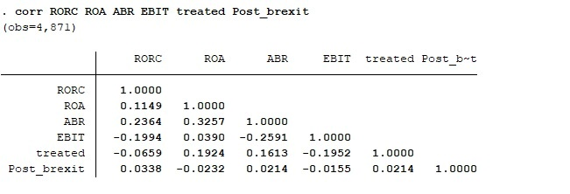

Figure 1 Correlation matrix

After running the correlation, we ran the regression model which is:

Leverage=β0 + β1 x RORC + β2 x ROA + β3 x ABR+ β4 x EBIT + β5 x treated + β6 x Post_brexit

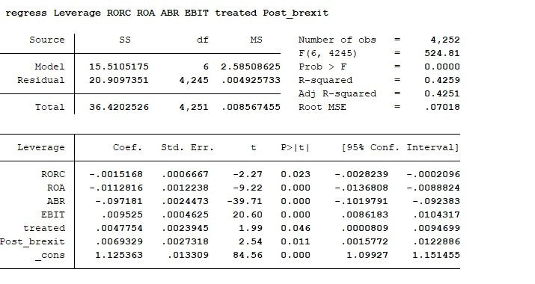

Figure 2 Regression model result

The R-squared value of 0.4259 suggests that the model explains approximately 42.59% of the total variation in the dependent variable. The adjusted R-squared value of 0.4251 takes into account the number of predictors and provides a slightly more conservative estimate of the model's explanatory power.

The coefficient of RORC, ROA and ABR are negative which means an increase in these variables will decrease the dependent variable which is leverage. The coefficient of treated, post_brexit, and _cons are positive which means if they increase the leverage will also increase. The p-value of all the variables is less than 5% which indicates that all of our independent variables are significant in explaining the dependent variable which is leverage.

The root mean squared error (RMSE) is 0.07018, representing the average difference between the observed values and the predicted values of the dependent variable.

After that to run the Hausman test to check whether random effect or fixed effect is good for our model, we ran the fixed and random effect regression. Based on the results of the Hausman test, the chi-squared test statistic (-19.66) is negative, which indicates that the model fitted to the data does not meet the asymptotic assumptions of the Hausman test. Due to the violation of assumptions, the results of the Hausman test cannot be interpreted in this case.

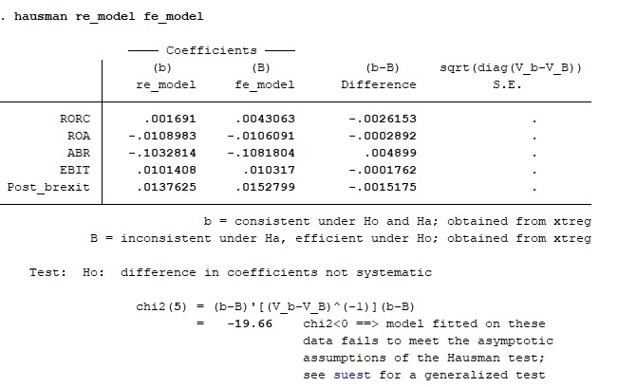

Figure 3 Hausman test results

After that, we ran the code of IV(2SLS). The results indicate that the R=squared is almost 43% indicating that the model explains approximately 42.69% of the variation in the dependent variable. The coefficients are the same as our regression model.

Under identification test: The Anderson canonical correlation LM statistic is 2361.922 with a p-value of 0.0000. The test indicates that the model is under-identified.

Weak identification test: The Cragg-Donald Wald F statistic is 2670.658. It exceeds the critical value at all maximal IV sizes, indicating weak instrument strength.

Sargan statistic: The overidentification test of all instruments yields a Sargan statistic of 34.584 with a p-value of 0.0000. The test indicates a rejection of the null hypothesis of valid instruments, suggesting that there might be overidentification problems.

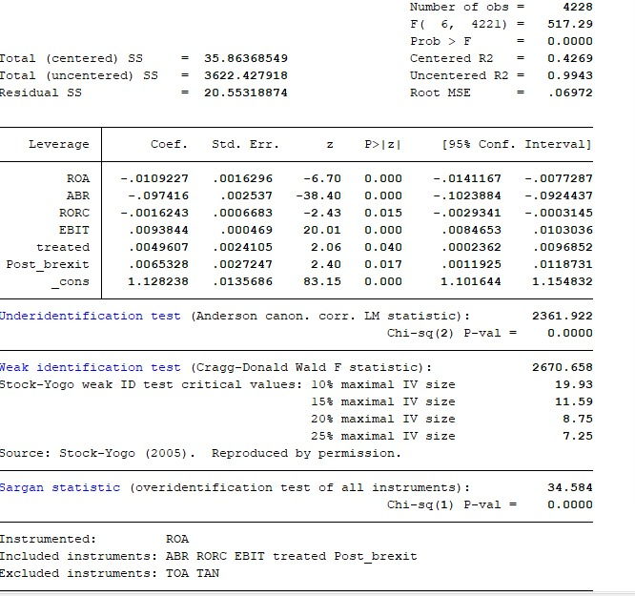

Figure 4 IVreg2 results

Then we ran the robust regression, which indicates that the R-squared of this model is 0.3617 indicating that the model explains approximately 36.17% of the variation in the dependent variable. The F-statistic is 129.95 with a p-value of 0.0000, indicating the overall statistical significance of the regression. Overall, the regression model suggests that Post_brexit, treated, and the interaction between Post_brexit and treated have significant effects on Leverage. Additionally, ROA, ABR, and EBIT also have significant effects on Leverage.

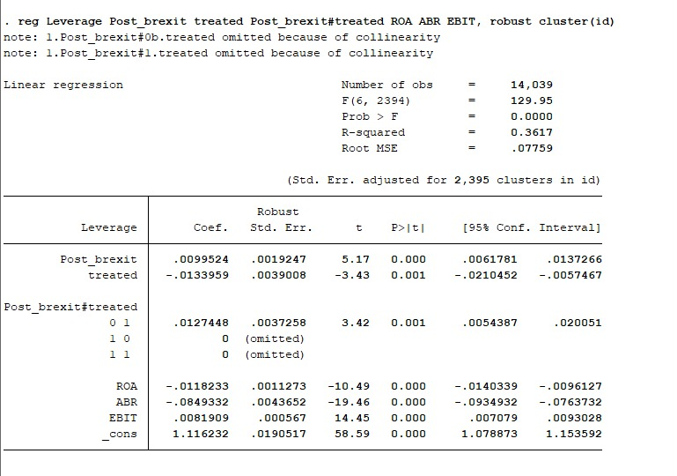

Figure 5 Robust regression results

After the robust, we ran the difference-in-difference command which compares the leverage variables before and after the control group and treated group. The DiD estimate, which represents the difference in the changes of "Leverage" between the treated and control groups, is -0.005, with a standard error of 0.006. The t-statistic for this estimate is 0.76, and the p-value is 0.450. Overall, the results indicate that there is no statistically significant difference in the changes of "Leverage" between the treated and control groups after the intervention. The p-value for the DiD estimate is greater than the significance level of 0.05.

Overall, the regression model suggests that Post_brexit, treated, and the interaction between Post_brexit and treated have significant effects on Leverage. Additionally, ROA, ABR, and EBIT also have significant effects on Leverage.

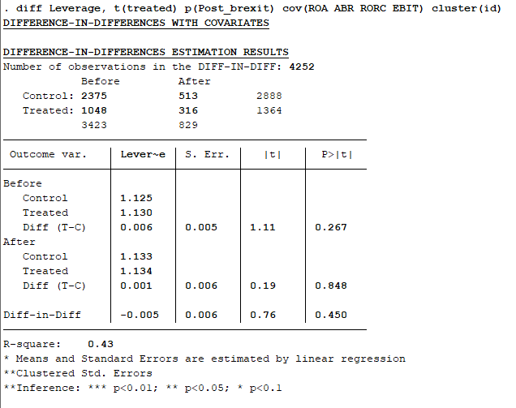

Figure 6 Difference-in-Difference results

Then we ran logit regression, the results indicate that the chi-square test statistic is 528.75 with a p-value of 0.0000, indicating the overall statistical significance of the logistic regression model. The pseudo-R-squared value is 0.0831, which indicates a relatively low level of explained variation in the dependent variable. The logistic regression model suggests that ROA, ABR, RORC, and EBIT are significant predictors of being treated. Higher values of ROA and ABR are associated with an increased likelihood of being treated, while higher values of RORC and EBIT are associated with a decreased likelihood of being treated. The intercept term (_cons) represents the log odds of being treated when all independent variables are zero.

`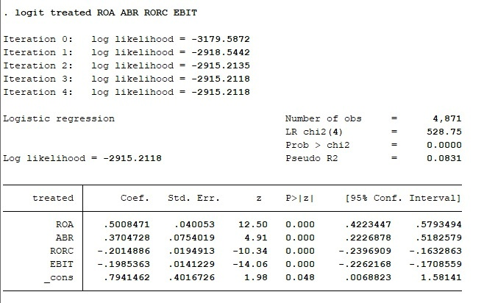

Figure 7 Logit results

Finally, we ran the tabstat command and the results show that the group with "treated" equal to 1 has higher mean values of ROA and ABR compared to the group with "treated" equal to 0. However, the group with "treated" equal to 1 has a lower mean value of RORC compared to the group with "treated" equal to 0. The mean value of EBIT is similar between the two groups.

The results of the regression study demonstrated that factors including Return on Assets (ROA), Asset-to-Equity Ratio (ABR), Return on Risk Capital (RORC), and Earnings Before Interest and Taxes (EBIT) have a substantial impact on company leverage. Leverage is impacted by these variables in statistically meaningful ways and with various coefficients.

## **Conclusion**

The results of the regression study demonstrated that factors including Return on Assets (ROA), Asset-to-Equity Ratio (ABR), Return on Risk Capital (RORC), and Earnings Before Interest and Taxes (EBIT) have a substantial impact on company leverage. Leverage is impacted by these variables in statistically meaningful ways and with various coefficients. By considering the variable "Post_brexit," the analysis looked at how Brexit affected corporate leverage. Positive and statistically significant was the "Post_brexit" variable's coefficient. This shows that Brexit has had a considerable overall influence on company leverage. This reinforces the significance of the study of previous literature studies conducted by other writers, which demonstrates that Brexit has a negative impact on leverage in some nations.

## References

1. BBC News, 2020. [Brexit: What you need to know about the UK leaving the EU - BBC News](https://www.bbc.co.uk/news/uk-politics-32810887)
2. Hassan, T.A., Hollander, S., Van Lent, L. and Tahoun, A., 2020. The global impact of Brexit uncertainty (No. w26609). National Bureau of Economic Research.
3. Rauh, J.D. and Sufi, A., 2010. Capital structure and debt structure. The Review of Financial Studies, 23(12), pp.4242-4280.
4. Aichele, R., & Felbermayr, G. (2015). Cost and benefits of the United Kingdom exit from the European Union.
5. Alagoa, H. (2017). Brexit, Trade, and the Wealth of Nations. Available at SSRN2985022.
6. Ando, K. (2017). Brexit: A new institutional economics perspective. European Association for Evolutionary Political Economy
7. Bahmani, M., Harvey, H., & Hegerty, S. W. (2013). Empirical tests of the Marshall-Lerner condition: a literature review. Journal of Economic Studies, 40(3), 411-443.Balassa,
8. Baldwin, R. (2013). The theory of economic integration (Routledge revivals). Routledge.
9. Becker, S. O., Fetzer, T., & Novy, D. (2017). Who voted for Brexit? A comprehensive district-level analysis. Economic Policy, 32(92), 601-650.Begg, I. (2017). Making sense of the costs and benefits of Brexit: challenges for economists. Atlantic Economic Journal, 45(3), 299-315
10. (PDF) Brexit: Causes and expected effects. Available from: https://www.researchgate.net/publication/339401935_Brexit_Causes_and_expected_effects [accessed May 30 2023].
11. Kotliński, K. (2018). The economic consequences of leaving European Union by Great Britain. Economics and Law, 17(2), 157-167.
12. Matthews, A. (2016). The Potential Implications of a Brexit for Future EU Agri‐food Policies. Euro Choices, 15(2), 17-23.
13. Filip Ž. Bugarčić, Marijana Simić | 161SCHOOL OF BUSINESS, 1/2019, 145-161Mugarura, N. (2018). The implications of Brexit for UK anti-money launderingregulations: Will the fourth AML directive be implemented or bebinned?. Journal of Money Laundering Control, 21(1), 5-21.
14. Mugarura, N. (2018). The implications of Brexit for UK anti-money launderingregulations: Will the fourth AML directive be implemented or bebinned?. Journal of Money Laundering Control, 21(1), 5-21.: Causes and expected effects. Available from: https://www.researchgate.net/publication/339401935_Brexit_Causes_and_expected_effects [accessed May 30 2023].
15. Ando, K. (2017). Brexit: A new institutional economics perspective. EuropeanAssociation for Evolutionary Political Economy

## **Appendix:**

Do-file

clear all

cd

import excel "C:\Users\EliteBook\Desktop\Econometricx\New_data.xlsx", sheet("Results") firstrow

drop AM AS BD BJ

reshape long ROE TotaldebtGBP rorc TotalequityGBP EBITGBP ROA TotalassetsGBP Assetbasedratio TangibilityGBP, i(BvDIDnumber) j(Year) string

encode BvDIDnumber, generate(ID)

drop BvDIDnumber

destring ROE TotaldebtGBP rorc TotalequityGBP EBITGBP ROA TotalassetsGBP Assetbasedratio TangibilityGBP, replace

ren *,lower

hist roe

hist totaldebtgbp

hist rorc

hist totalequitygbp

hist ebitgbp

hist roa

hist totalassetsgbp

hist assetbasedratio

hist tangibilitygbp

gen ROE = log(roe)

gen TOD = log(totaldebtgbp)

gen RORC = log(rorc)

gen TOE = log(totalequitygbp)

gen EBIT =log(ebitgbp)

gen ROA = log(roa)

gen TOA = log(totalassetsgbp)

gen ABR = log(assetbasedratio)

gen TAN = log(tangibilitygbp)

hist ROE

hist TOD

hist RORC

hist TOE

hist EBIT

hist ROA

hist TOA

hist ABR

hist TAN

gen Leverage= TOD/TOE

destring year, replace

generate brexit_date = date("2020-01-30", "YMD")

format brexit_date %td

gen treated = 0

replace treated = 1 if country == "United Kingdom"

gen Post_brexit = 0

replace Post_brexit = 1 if year >= 2020

drop if ROE==.

drop if EBIT==.

corr RORC ROA ABR EBIT treated Post_brexit

regress Leverage RORC ROA ABR EBIT treated Post_brexit

sum

sort country year

by country year: summarize

xtset id year

xtreg Leverage RORC ROA ABR EBIT treated Post_brexit, i(id) re

estimates store re_model

xtreg Leverage RORC ROA ABR EBIT treated Post_brexit, i(id) fe

estimates store fe_model

hausman re_model fe_model

ivreg2 Leverage (ROA = TOA TAN) ABR RORC EBIT treated Post_brexit

reg Leverage Post_brexit treated Post_brexit#treated ROA ABR EBIT, robust cluster(id)

diff Leverage, t(treated) p(Post_brexit) cov(ROA ABR RORC EBIT) cluster(id)

logit treated ROA ABR RORC EBIT

predict pscore, xb

tabstat ROA ABR RORC EBIT, by(treated) statistics(mean)

save new_data.dta, replace